The first image that is shown down below displays the webpage, but the CSS was changed to make the words that are presented to be green. Based on the recent changes of the color to the words the new styling would affect the user’s vision while trying to read the words on the webpage. The recent changes that were made to the words of the webpage would affect the user reading experience, so the best choice of action would be to change the color of the words from green to black because that is the usual color format that is used for words.

1.



The second image that is shown down below displays the webpage, but the CSS was changed to make the background of the webpage a different color. The original background of the webpage was white, but I changed the background to the color red. The color of the background does not compliment the images and words that are being shown throughout the website. The decision that I have made regarding the recent change to the background is to not keep the color red as the background. The color does not go well with the words and pictures that are being displayed, and the color may confuse the users that are viewing the website.

2.

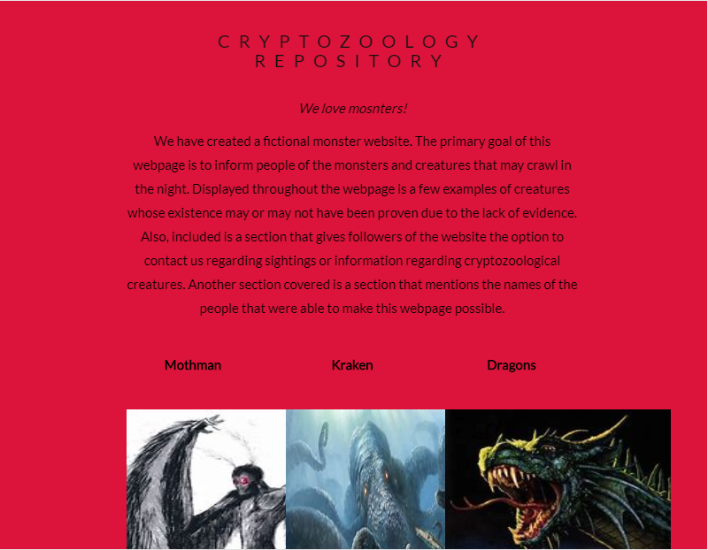

The third image that is shown down below displays the webpage, but the font that is used for the wording of the webpage is removed so that there is no Font style included. The text of the website has completely changed by removing the font because there is no spacing between each word. The styling of the words would affect the user’s vision due to how small and close the words have become after removing the font from the website. The best option that would benefit the site and the users would be to include a font with the wording of the webpage to help separate the words and so that each word and sentence can be read without any difficulties.

3.

